## Battle Turtles

### Tips and tricks

If you have run a program and it didn't quite work, you will need to **Restart** the CPU.

This will set the Program Counter back to 0.

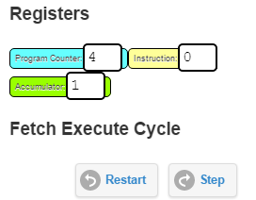

**Program order**

* Data labels must be at the bottom of your program.
* Instructions: e.g. LDA Forward / OUT 1
* End of program: HLT
* Finally, data labels: e.g. Forward DAT 0

### Reminders

* OUTput devices: 1 = movement and 2 = steering
* For movement: 0 = forward and 1 = backward
* For steering: 0 = north, 2 = east, 4 = south and 6 = west

### What a program looks like

|  |  |
| --- | --- |
| // Commands  LDA Forward  OUT 1  HLT  // Data labels  Forward DAT 0  Backward DAT 1 | Loads Forward (0) into ACC  Move forward 1 square. Sends Forward (0) to output device 1 (movement)  Stop, end of instructions  Create a variable called Forward that stores 0  Create a variable called Backward that stores 1 |

|  |  |
| --- | --- |
| // Complete the commands  LDA  OUT  LDA  OUT  LDA  OUT  HLT  // Data labels  Forward DAT 0  Backward DAT 1  North DAT 0  East DAT 2  South DAT 4  West DAT 6 | Load Forward and move 1 square forward  Load East and turn to face east  Load Forward and move 1 square forward |